*Luiza Cavalcanti (2020309) & Gabriel Antoniolli (2020352)*

*Lecturer: Dr Muhammad | Theory and Practical*

**

Cross Platform Development CA3 - Electricity Bill Calculator

Link Video presentation:

<https://drive.google.com/file/d/1iYKBuBEsgF5G5PbNLxNrv-LQLctopbnQ/view?usp=sharing>

GitHub Link for code collaboration: <https://github.com/luizaalbuquerque/eletricityBill.git>

Table of Contents

REPORT 2

1. Design of the application 2

3. Calc of electricity bill: 2

4. Execution of the application + code 3

5. StudentID + folder and files of the application: 4

6. Testing strategy: 5

7. Functionality + video presentation (7 min duration): This section is explained by the video recording. 5

All code screenshots: 6

Assignment Contribution: 14

Referencing: 15

REPORT

1. Design of the application for electricity users (UML used for the wireframe: Draw.io).

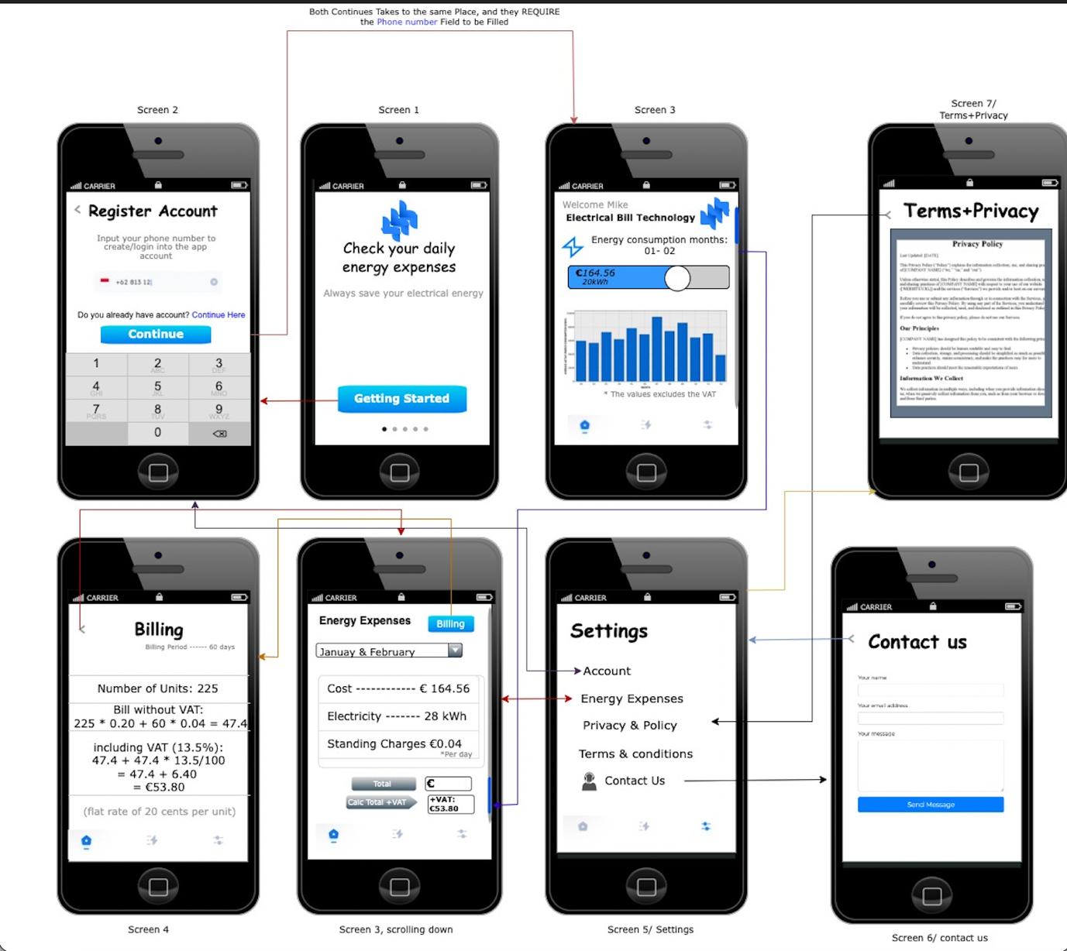

1. It was implemented Electron Framework on the application. (see on code references)
2. Calc of electricity bill: this calculation was done in two stages, firstly the cost without VAT and then adding up VAT tariff. See logic below.

// calc without VAT

function priceNoVAT() {

var noVAT = 0;

var unitRate = document.getElementById('unitRate').value;

if (unitRate == '') {

// error message for empty submit

let errMessage = document.getElementById('errMessage');

errMessage.innerHTML = ' Please Insert the Unit Rate';

errMessage.style.color = 'red';

errMessage.style.visibility = 'visible';

return noVAT;

} else {

// if not empty, perform the calc

noVAT = ((unitRate * 0.20) + (60 * 0.04));

document.getElementById('errMessage').style.visibility = 'hidden'

return noVAT;

}

}

// function for calc with VAT

function priceWithVAT() {

const noVATPrice = priceNoVAT();

const unitRate = document.getElementById('unitRate').value;

// adding up VAT

const VAT = noVATPrice + (noVATPrice * (13.5 / 100));

const result = document.getElementById('resultBox');

// rounding value up to 2 decimal places

result.innerHTML = VAT.toFixed(2);

// editing table display

document.getElementById('countLabel').style.visibility = "visible";

document.getElementById('euroIcon').style.visibility = "visible";

document.getElementById("cost").innerHTML = VAT.toFixed(2);

document.getElementById("unit").innerHTML = unitRate;

}

1. Execution of the application + code (Application Running in a MAC system, with the use of electron, see below), was used the command “*electron .”* inside the application folder, through the terminal, evidence of first page on load.

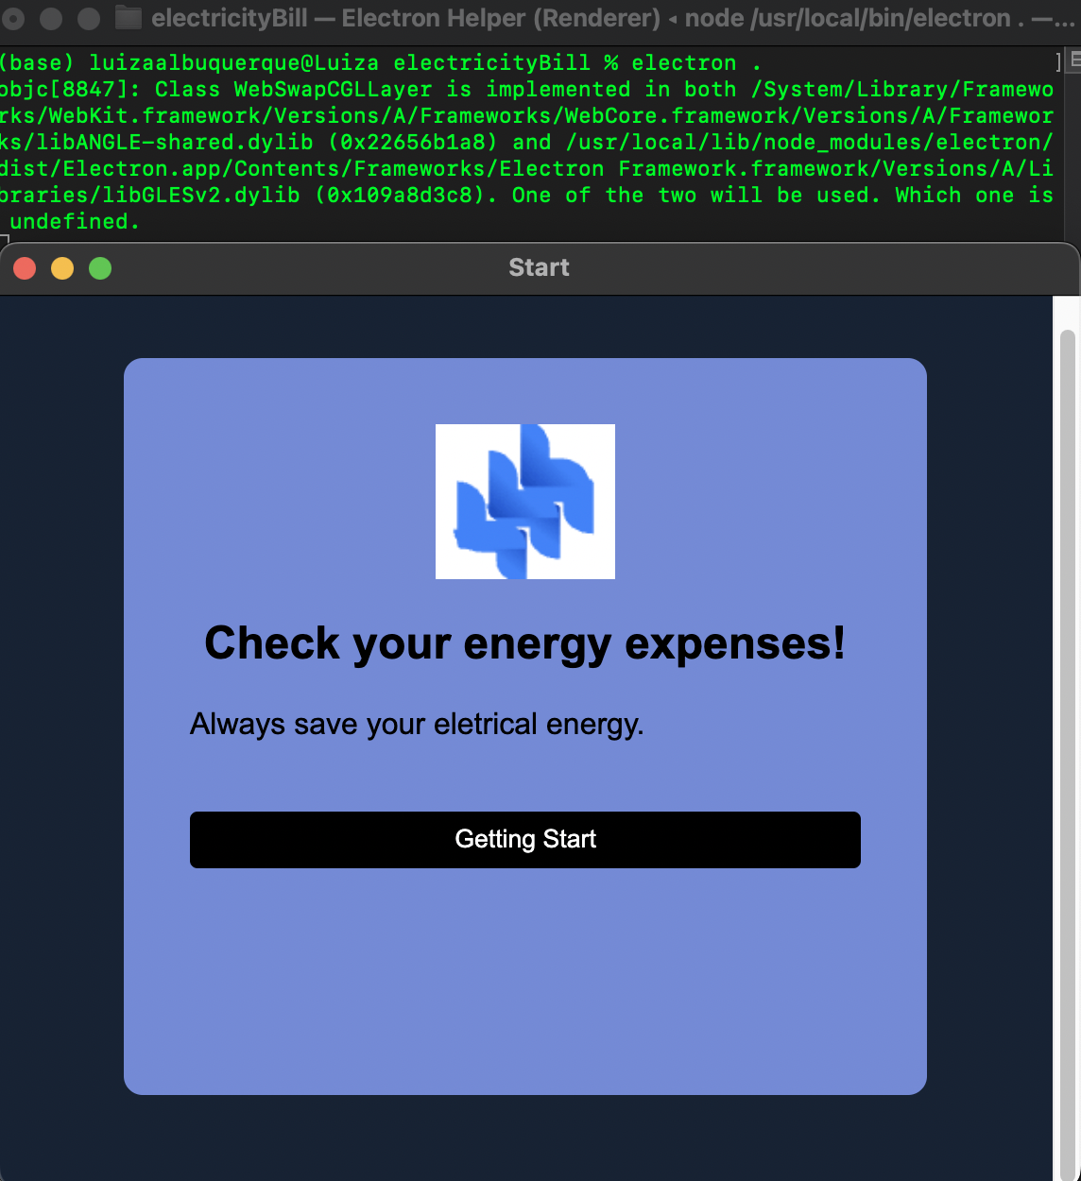

## StudentID + folder and files of the application:

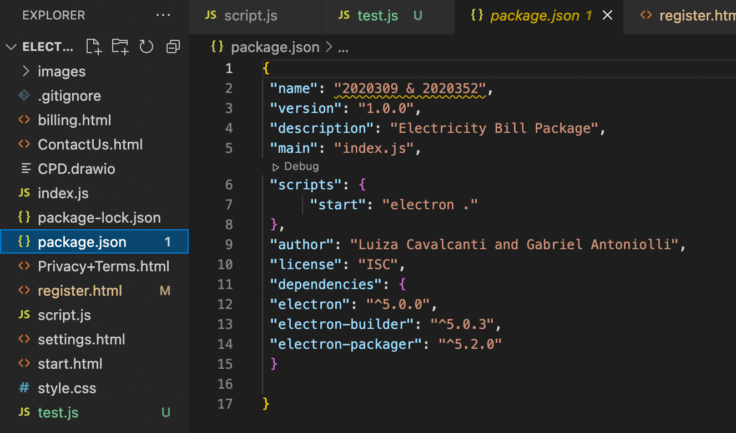

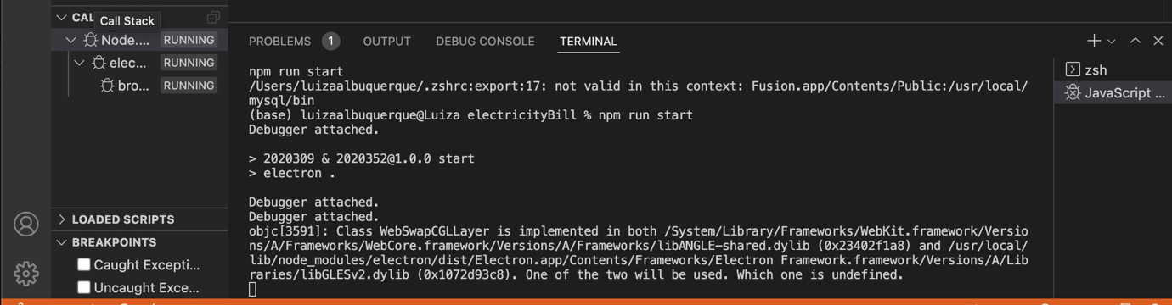

## Testing strategy:

Unit testing was made by the use of Mocha framework for node.js dependencies testing. Node_modules were installed via terminal/CMD as well as mocha. It was created a folder called ‘test’ within a file called search.test.js, in which was added a pre-made snip code, to run it was used the command “node_modules/ .bin/mocha. Unit testing was passed from pending to passing test and followed by and added/extra debugging section, in which is evidenced below.

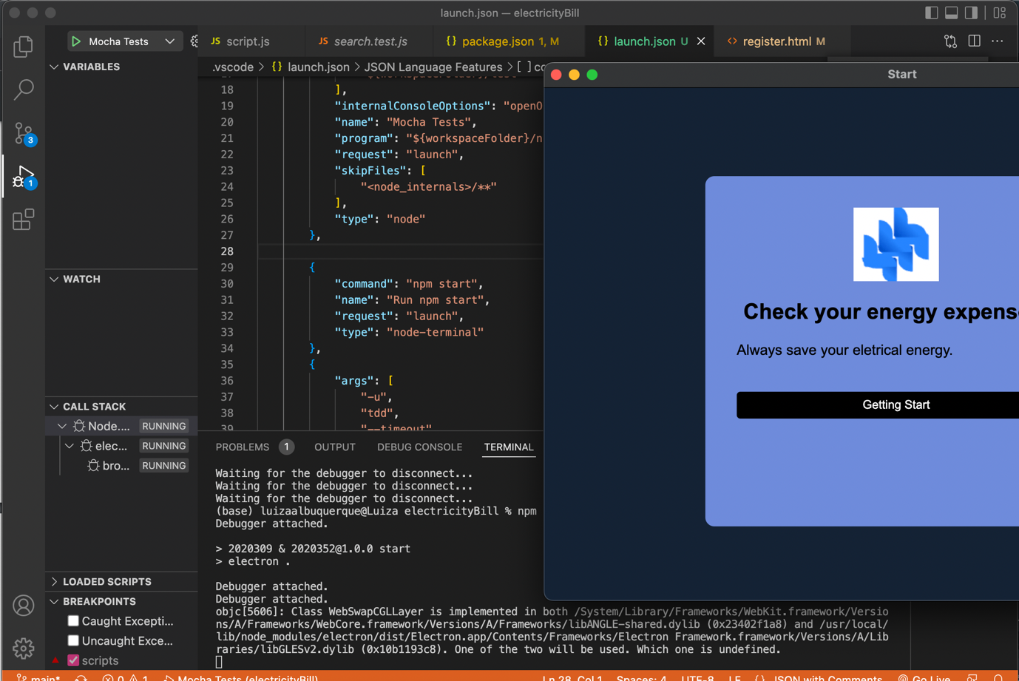

## Functionality + video presentation (7 min duration): This section is explained by the video recording.

## All code screenshots:

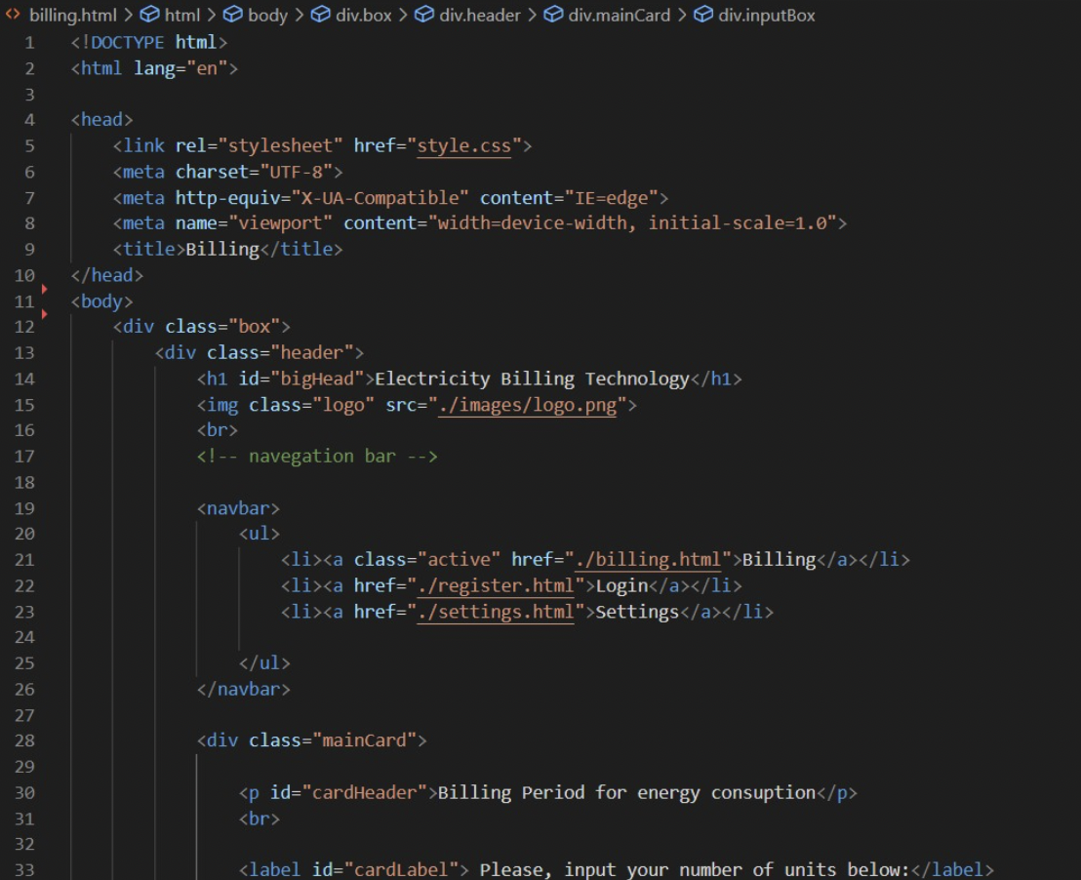

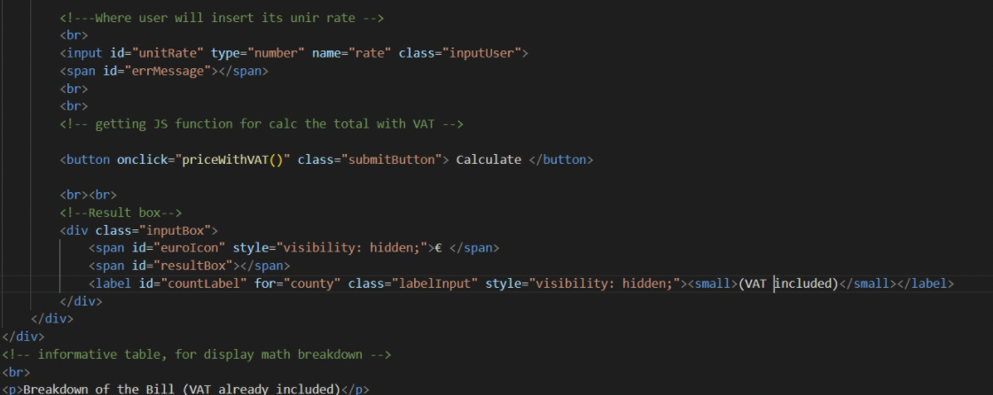

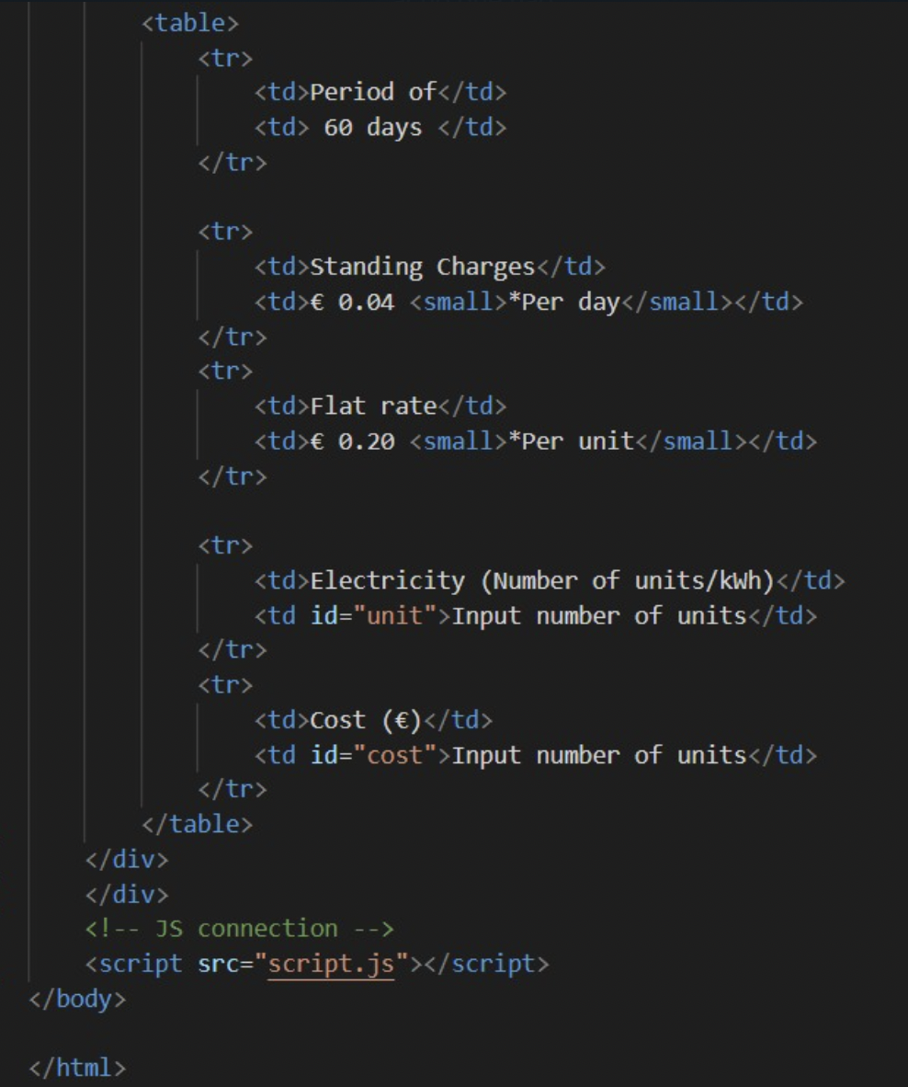

**Contact us Part1**

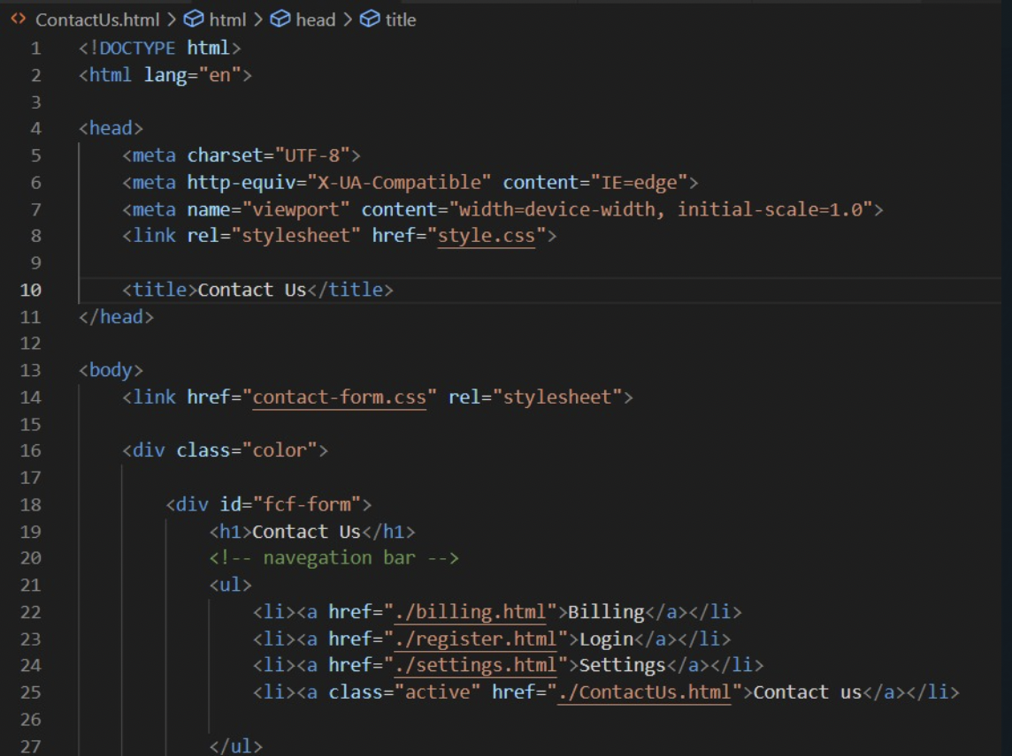

**Contact us Part2**

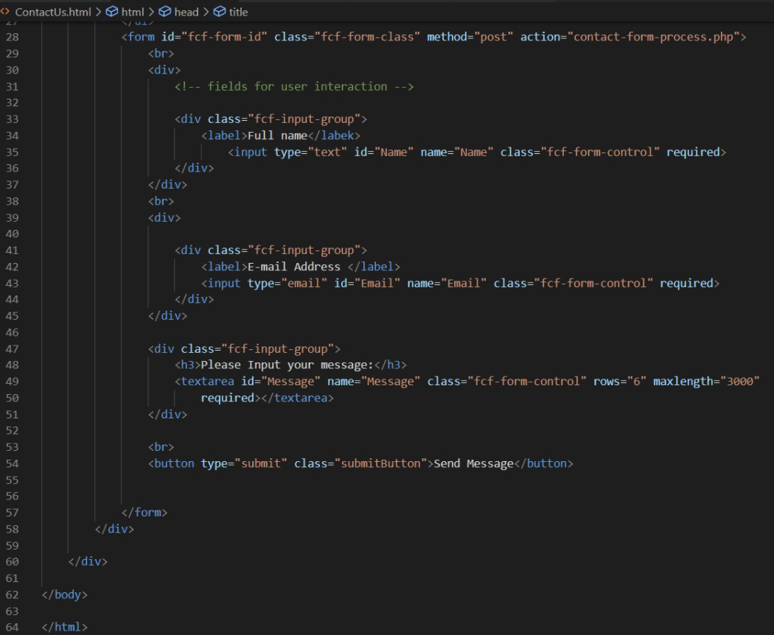

**Electron.js**

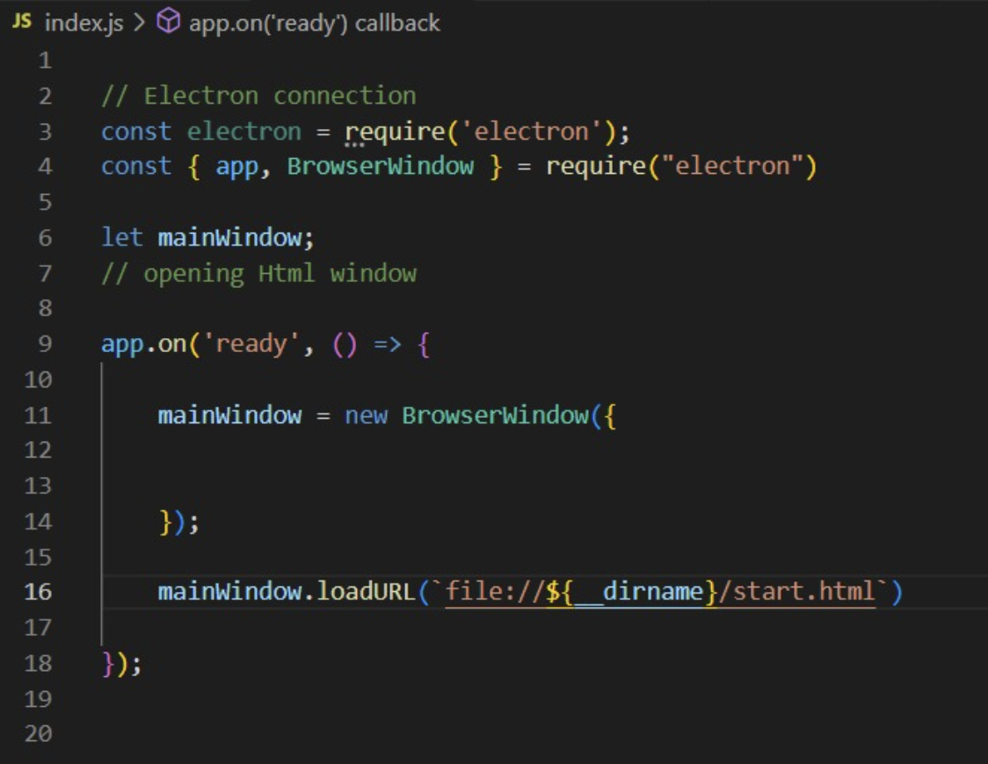

**Package.json**

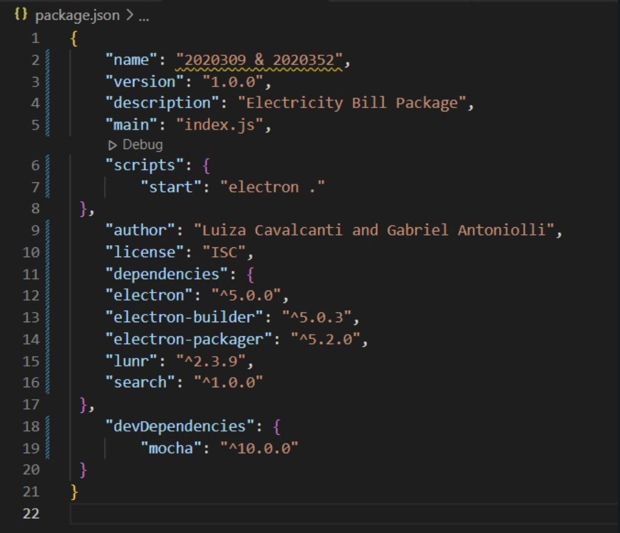

**Privacy terms Part1**

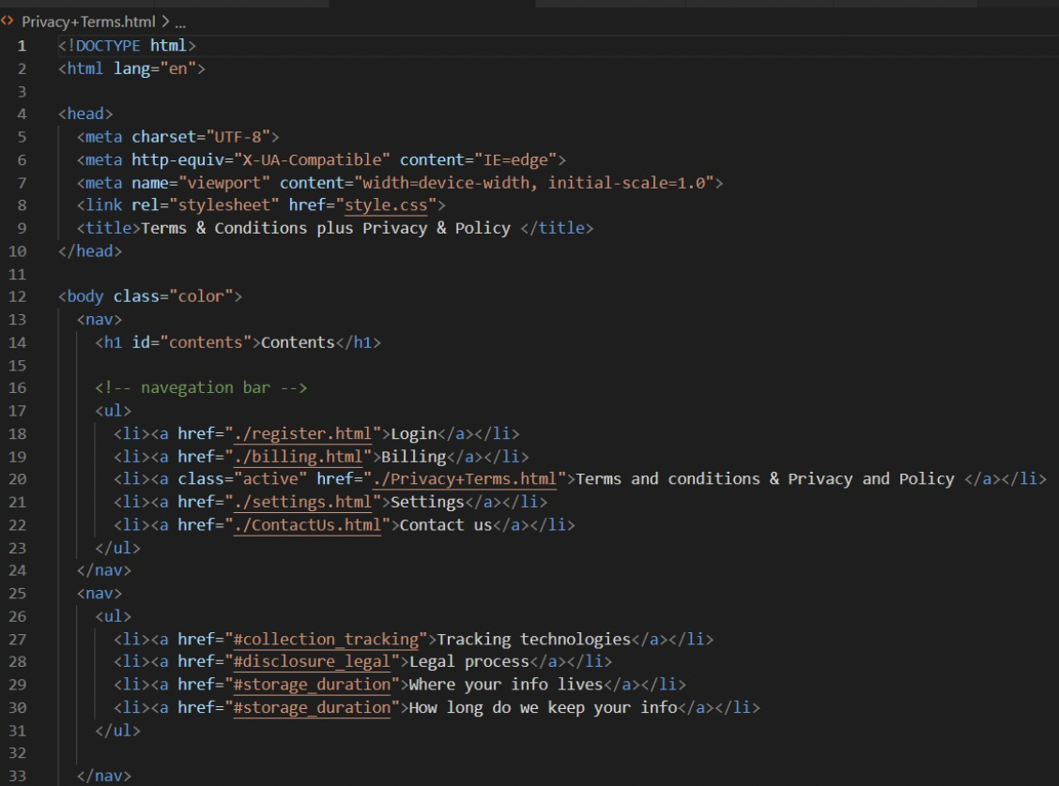

**Privacy terms Part2**

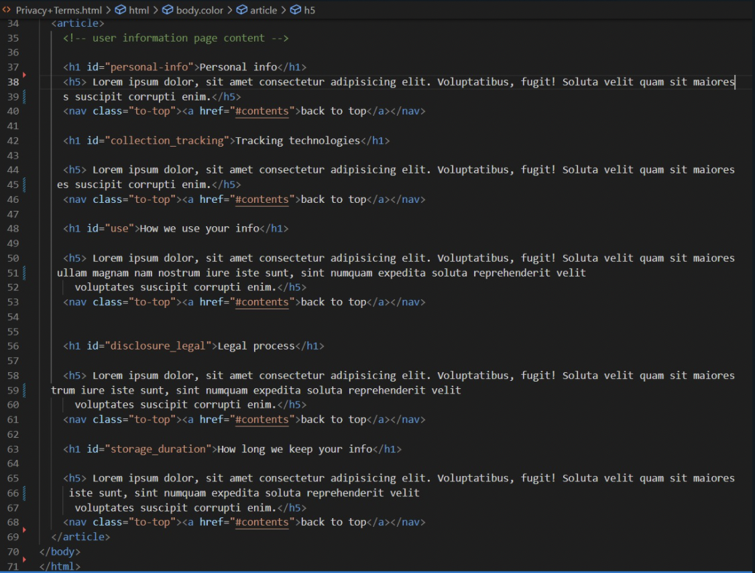

**Register**

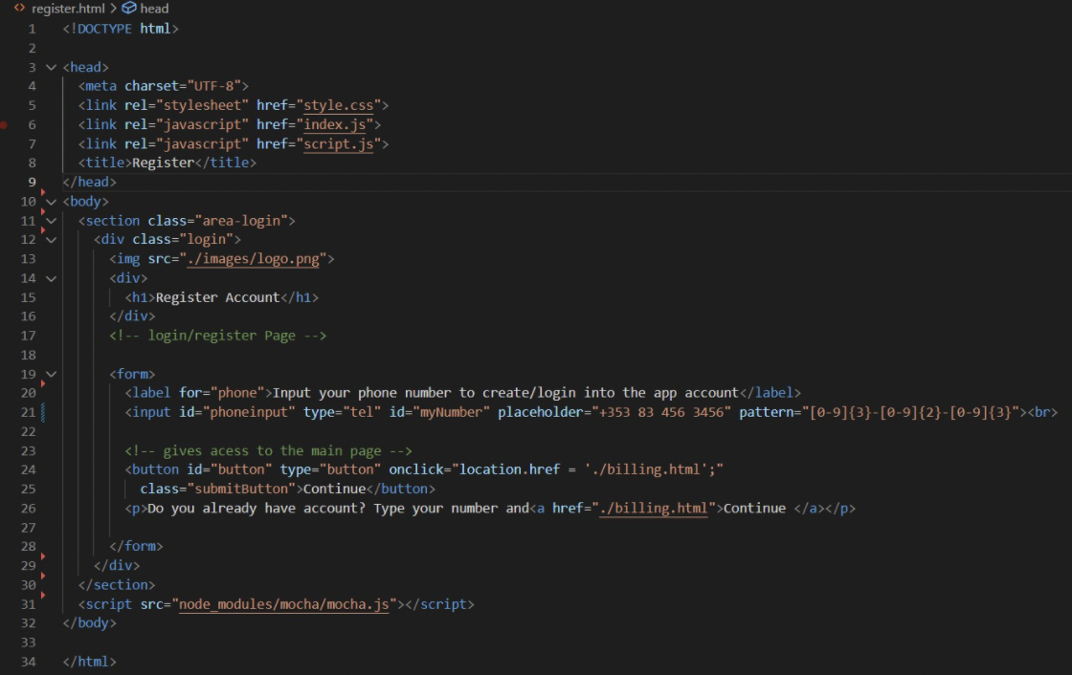

**Script.js Part1**

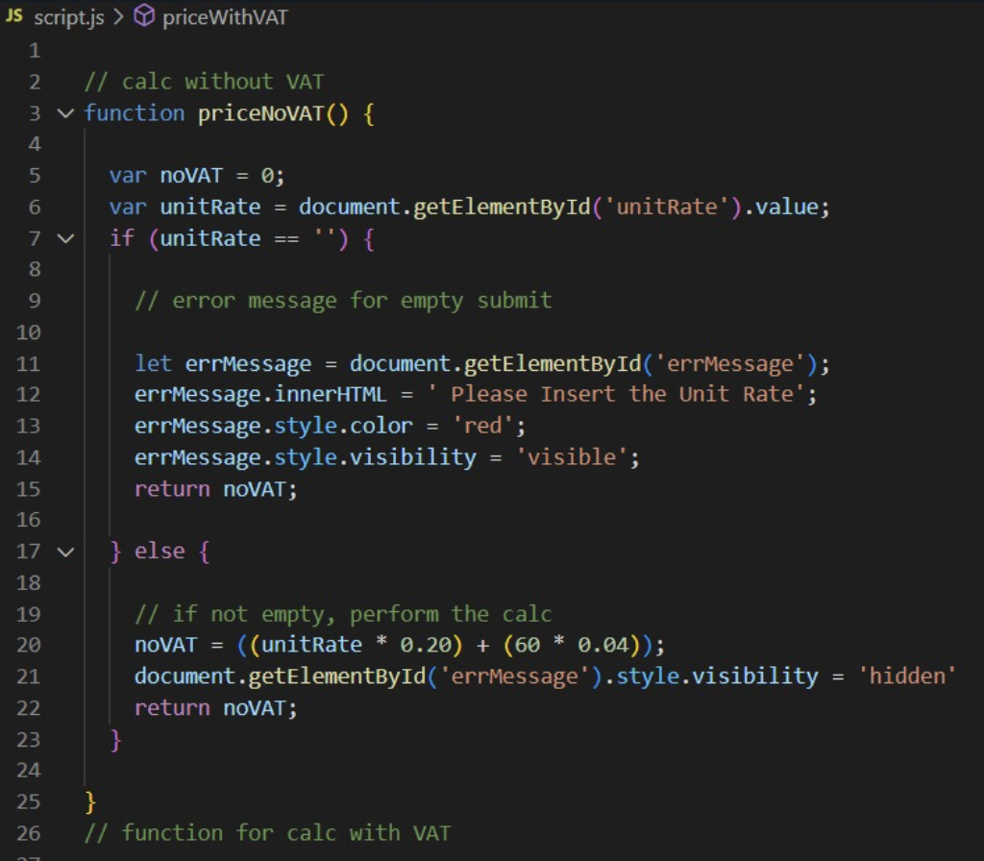

**Script.js Part2**

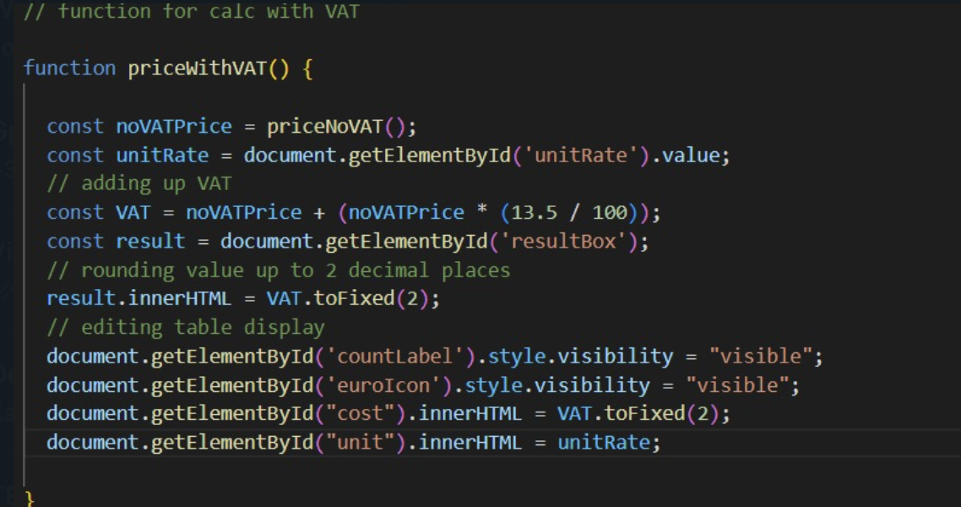

**Settings.html Part1**

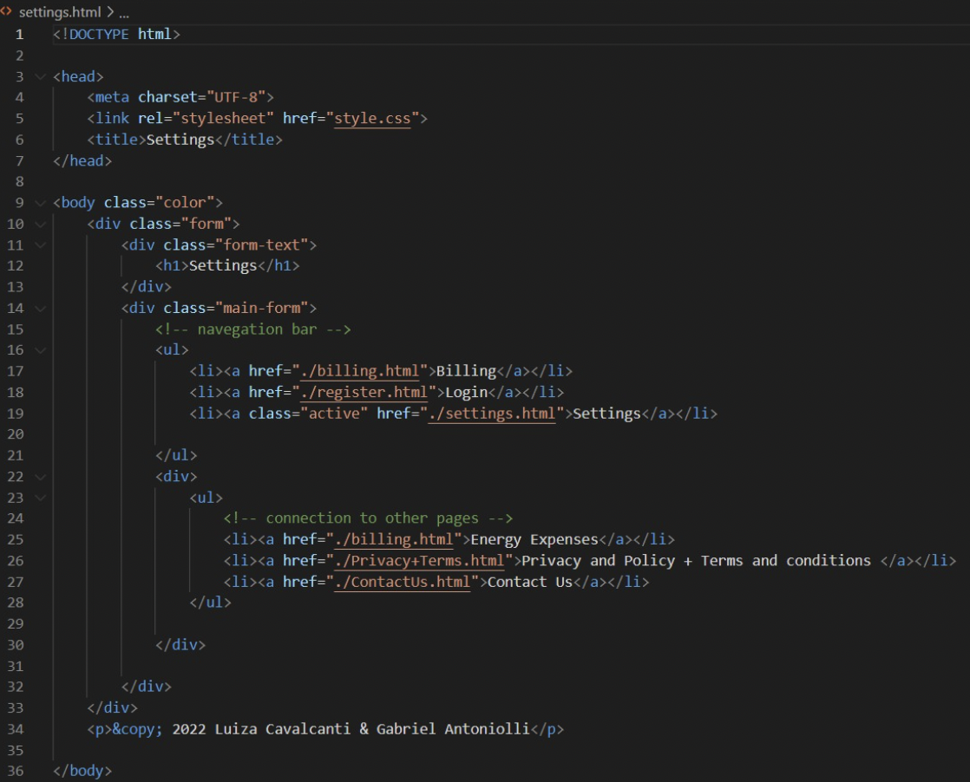

**Start.html**

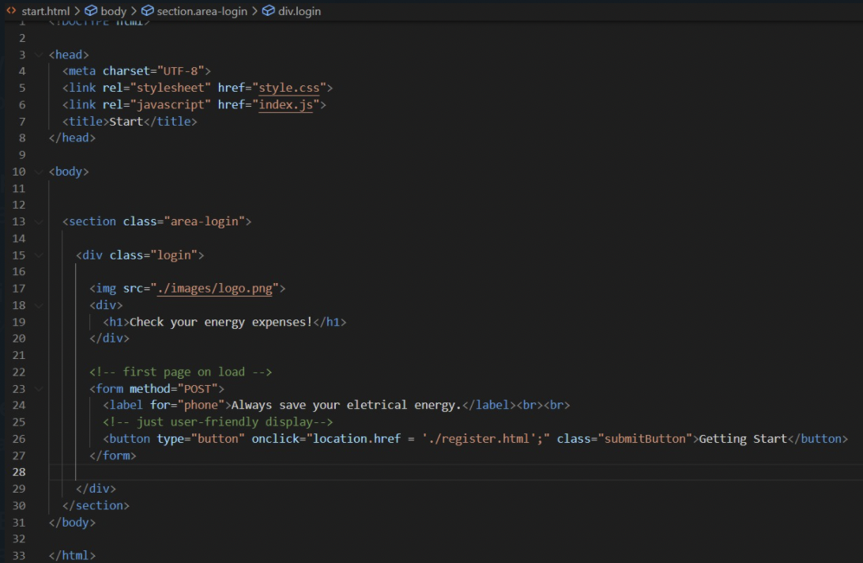

**CSS Part1 Part2**

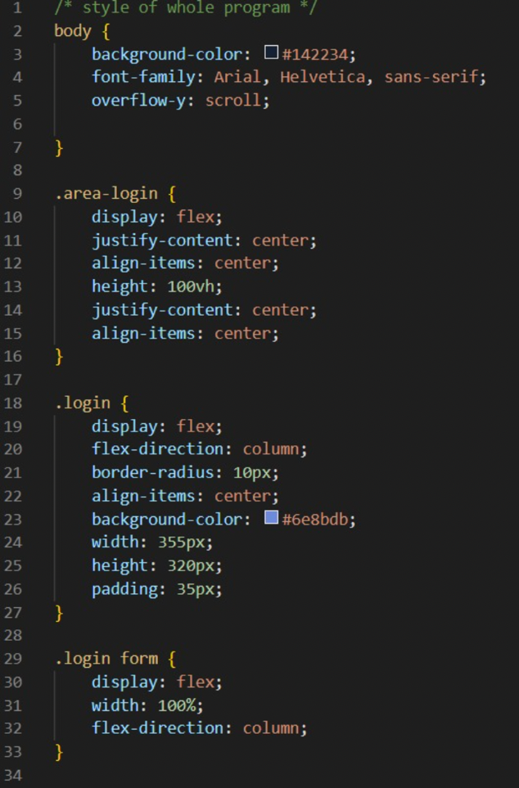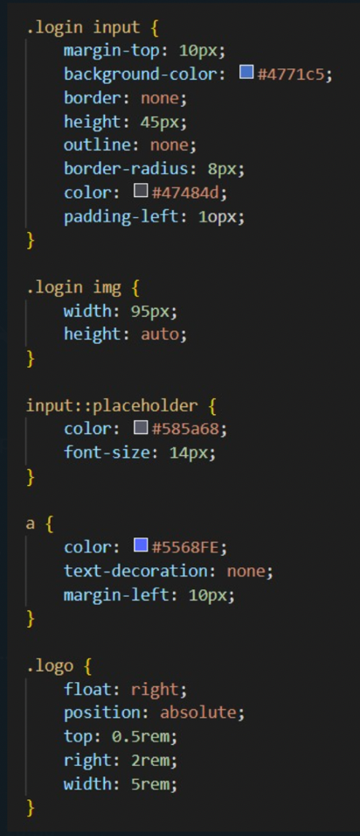

**Part3 Part4**

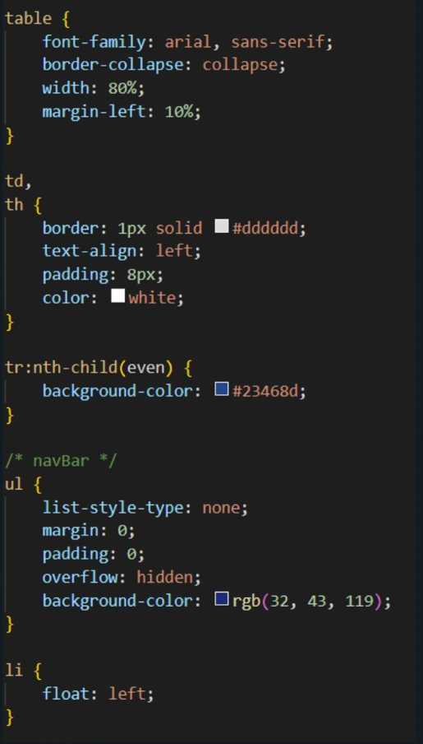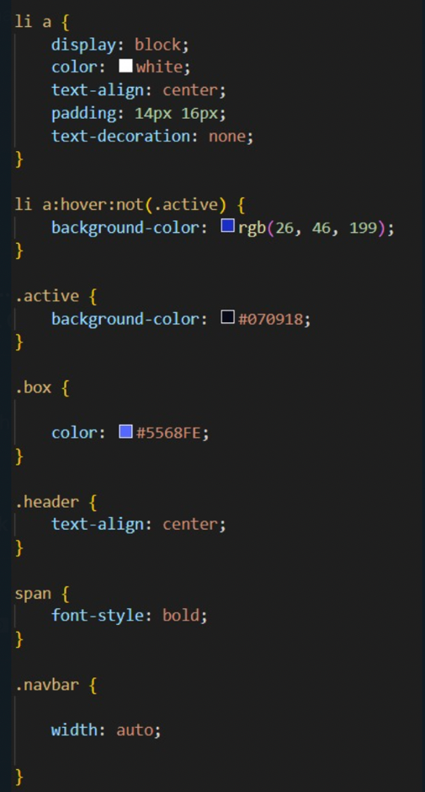

**Part5 Part6**

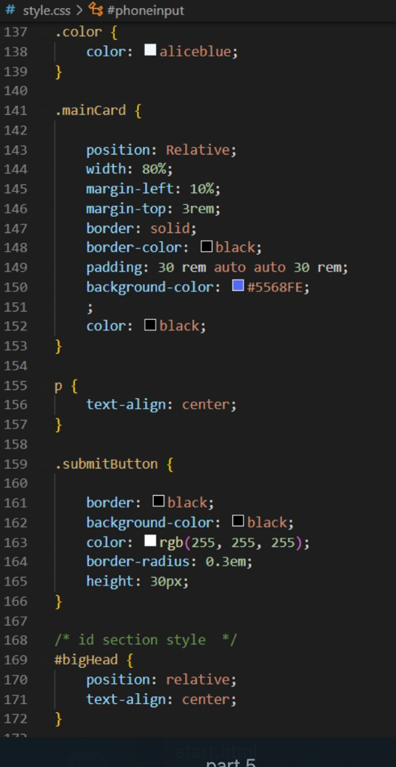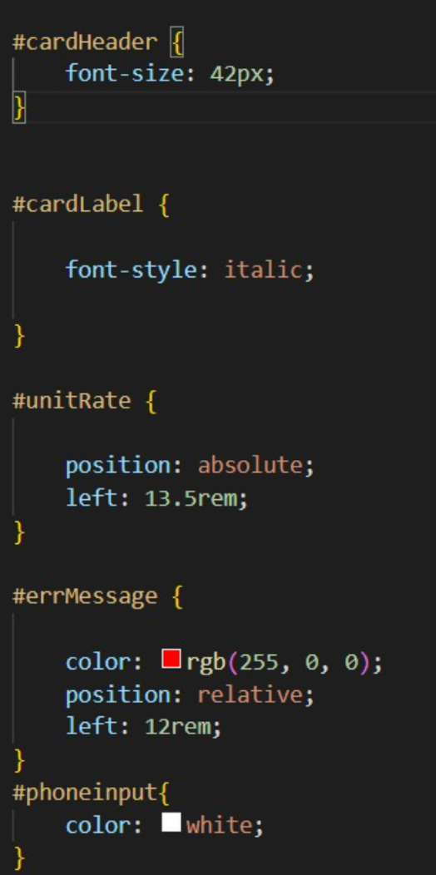

## Assignment Contribution:

* Wireframe: Idea was discussed between both students, but the first design idea was made by student 2020309.
* Choice of which framework used: was agreed by both students.
* Calc of electricity: student 2020352 did the JS implementation and the front-end + breakdown of Math was made by student 2020309.
* Execution of code shown in the report: was made by student 2020309, but application execution was tested by both students, making use of two different operational systems, such systems were the following: Mac and Windows.
* Title with studentIDs: made by student 2020352 and images and folder containing the application files was made by student 2020309.
* Strategy for testing: first testing using mocha, was student 2020352 idea and both students worked together for the testing section, as for debugging, student 2020309 inputted the extra resourced and it was approved by the other student.
* Validation of users: field and front-end created by student 2020309, validation done by student 2020352.
* Demonstration of code and functionality made by student 2020352, in video format, which can be accessed through the link on the cover page, by the ZIP folder on CDP-Main> Recording or as follow: link: <https://drive.google.com/file/d/1iYKBuBEsgF5G5PbNLxNrv-LQLctopbnQ/view?usp=sharing>
* Full report was done by student 2020309 and checked by student 2020352.
* Video record: made by student 2020252 and reviewed by student 2020309, who also made inputs in what to add to the recording.

## Referencing:

Information were mostly took from lecturer classes, classes materials and previous knowledge of the subject. A few lines of code were searched on the internet, but the logic used in this application was purely from the above students.